Calculus Based Physics I: LAB
PHYS 2110 WA
Date: June 3, 2023
Isaac Abella

Experiment 3
Series and Parallel Resistors

Group:
Isaac Abella
Objectives:
The objective of this experiment is to verify Ohm’s Law applied to (a) series resistors, (b) parallel resistors, and (c) a module of parallel resistors in series with another resistor.

Equipment
A computer with internet connection, paper, pencil, calculator (ti-84 plus CE/ti-30sx II), and PHET virtual software.

Theory (I)
Ohm’s law simply states that the ratio of voltage across an electric resistor to the current through that resistor is a constant called the electric resistance of that resistor.
If V is in volts and I in amps, R will be in ohms/Ω. The preferred version of this formula is V = RI

Series resistors experience the same current, but generally have different voltages. In a series circuit, the current I is the same everywhere.

Voltage Across different resistors are different. The battery Voltage Vbat divides among the three resistors R1, R2, and R3 are proportional to their resistances such at:
Vbat = Vab + Vbc + Vcd, (1)

Also, for a series resistors:

Rad = Rab + Rbc + Rcd, (2)

Procedure
After opening the PHET laboratory for Circuit Construction, a simple circuit system was created, modeled after Figure 1.1 inside the experiment 3 lab manual. Then inside of the applet, the three resistors where assigned R₁, R₂, and R₃. (From left to right). The battery in the circuit was then configured to 90.0 Volts, and the resistors where set to the proper resistance per trial 1 & 2 requirements.

Then, Total resistance was calculated after the total of the resistors were summed and recorded to table 1. After total resistance was recorded, the current flow of the circuit was calculated at each resistor with Ohm’s law: V_{bat} = R_{eq} * I or I = V_{bat} / R_{eq}. All values were then added to table 1.

Once each resistor was calculated, V = RI was then used to calculate the voltage across each resistor, which was then added to table 1. After trial 1 was finished and the percent errors were added. The key that was included in the circuit was turned on. Then the resistor values were changed to follow trial 2, and then the current and voltage values were calculated and added accordingly.
Data (1)
Given and Measured:

Table 1
Trial | V_{bat} | R₁ | R₂ | R₃ | R_{eq} |  | I  Amps  V/R_{eq} | V₁=  R₁I  Volts | V₂=  R₂I  Volts | V₃=  R₃I  Volts
1 | 90.0 | 11 | 22 | 33 | 66 | Calculated  Measured  % Error | 1.364  1.36  0.294% | 15.004  15.0  0.027% | 30.008  30.0  0.027% | 45.012  45  0.027%
2 | 18.0 | 15 | 25 | 45 | 85 | Calculated  Measured  % Error | 1.059  1.06  0.094% | 15.885  15.88  0.031% | 26.475  26.47  0.019% | 47.655  47.65  -0.010%

Calculations (I)
Calculations for Case 2 that lead to the accepted Value range:

Amp Calculation was I = V_{bat} / R_{eq} => 90.0 / 85.0 = 1.059 Amps
Then the following equation was used to calculate the Volts for each resistor: V = R/I
V₁ = 15×1.059 = 1.364
V₂ = 25×1.059 = 26.475
V₃ = 45×1.059 = 47.655

Comparison of the Results (i)
Corresponding to every measured value, there is an accepted value. To calculate each error on each resistor, the following equation was used, then added to table 1 above:

II) Parallel Resistors:

Theory (II):

Parallel resistors experience the same voltage, but generally different currents. A typical parallel module is shown inside the lab manual.

To develop a formula that calculates the equivalent resistance between Points a and b, also see figure 2 inside the lab manual. Name this equivalent resistance R_{ab}. To find R_{ab} that can do the job of the three parallel resistors R₁, R₂, and R₃, it is important to emphasize that current I at Point a divides into sub-currents I1, I2, and I3. At Point B, the sub-currents I₁, I₂, and I₃ merge to form I again. We may write: I = I₁ + I₂ + I₃ (3) in which I = V_{ab} / R_{ab}, I₁ = V_{ab}/R₁, I₂ = V_{ab}/R₂, and I₃ = V_{ab}/R₃.

Substitution of the above four in Equation 3 results in:

Then dividing through by Vab, the equation changes to:
Rab = 1 / (1/R1 + 1/R2 + 1/R3 ). (4)
R₁, R₂, and R₃ all together draw the same current from the battery that R_{ab} would draw if replaced them. R_{ab} is the “equivalent resistance” between a & b.
Note that the voltage across each of the resistors is Vab. If we neglect the small voltage drop across the ammeter, the voltage Vab is equal to the battery voltage Vbat. This is because there is no any other circuit element between Point a and the battery, or between Point b and the battery to cause a voltage drop. The ammeters are just measuring devices and does not contribute to significant voltage drop. The voltage drop across an ammeter is usually neglected.
Equation (4) calculates the equivalent resistance R of the three parallel resistors R₁, R₂, and R₃.
Procedure (II):
After clearing the tabletop from theory 1’s procedure. A new circuit loop was constructed following figure 2.1 in the lab manual for experiment 3. This circuit loop would incorporate a parallel resistor series with 3 resistors. Each would be named and assigned a resistance value given inside the lab manual.
For the first procedure, the battery and resistors were set to the following values in Table 2 in the data section, then total current and the voltage of the battery were calculated and were then added to the table.
Current values for each resistor terminal was then calculated first, then verified and checked for error using the circuit loop. The formula used for the current calculation was Vbat/Rn.
This procedure was conducted for case 1 & 2, with the values changed per case and calculated as such.

Data (II):
Given and Measured:
Table 2:
Case | V_{bat}  (V) | R₁  (Ω) | R₂  (Ω) | R₃  (Ω) |  | V₁ = V₂ = V₃  Vbat  (Volts) | I(main)  V_{bat}/R_{ab}  (amps) | I1  V_{bat}/R₁  (amps) | I2  V_{bat}/R₂  (amps) | I3  V_{bat/}R₃  (amps)
1 | 120 | 40.0 | 60.0 | 120.0 | Calculated  Measured  % Error | 120  120  0% | 11  11.00  0$ | 3  3.00  0% | 2  2.00  0% | 6  6.00  0%
2 | 90.0 | 45.0 | 45.0 | 90.0 | Calculated  Measured  % Error | 90  90  0% | 5  5.00  0% | 2  2.00  0% | 2  2.00  0% | 1  1.00  0%

Calculation (II):
Calculations for Case 2 that lead to the accepted value range:
Calculating the Vbat was just taking the battery voltage and adding up to the Vbat. Since this is a parallel circuit, each resistor has 120 volts, and the total would Vbat would be 120 V.
To calculate the I main current, we have to take the reciprocal of the resistance and add them together to get 1/45 + 1/45 + 1/90 to get 1/18. Then dividing Vbat by Rab we get 90.0/18.0, which is just 5.
Getting the amps of all the resistors was just taking the Vbat and dividing by the resistance of each resistor:
R1 = 90/45 = 2
R2 = 90/45 = 2
R3 = 90/90 = 1 We can then verify that these all add up the main current 5 amps.
Comparison of the Results (II):
Corresponding to every measured value, there is an accepted value. To calculate each error on each resistor, the following equation was used, then added to table 2 above:

III) A Parallel Module in Series with Another Resistor:

Theory (III):

Figure 3 as shown inside the lab manual shows that a parallel module between Points a and b in a series with another resistor between Points b and c. In the figure, the battery voltage partially drops across ab and partial across bc. It is then logical to write:

Vbat = Vab + Vbc . (5)
The parallel module R₁, R₂, and R₃ may be replaced by Rab given by

This equation is good only for the parallel portion. To find the total resistance of the circuit, one may write:

Once the total resistance R_{ac} is determined, the main current I can be calculated by using Ohm’s law:

The total resistance R_{ac} determines how much current I, the main current, the battery can push through. Ammeter A in figure 3.1 inside the lab manual is a low resistance device, and its resistance may be ignored.

When I is determined, it can be multiplied by R_{ab} to calculate V_{ab}. It can also be multiplied by R_{bc} to calculate V_{bc}.

When V_{ab} is calculated, Ohm’s law may be used again to calculate I₁, I₂, and I₃, as follows:

Procedure (III):

After the tabletop was reset to blank, a new circuit loop was constructed to follow figure 3.1 in the lab manual for experiment 3. This circuit loop included a 4th resistor that would be used in addition to a parallel loop used in procedure 2.

After the loop was constructed, the total resistance and resistance of the resistors were calculated as R123 and Req, to account for the additional resistor, then the switch was turned on in the loop to verify the results of the calculations.

After calculating the main current and the Vbat, the voltages of the fourth resistor were then calculated and V123 was set = to R123I. All the values were then added to the table down below in the data category.

Currents 1 – 4 were also calculated, added to the table, and then checked for their error percentage.
Then specific measurements were made to follow the procedure by doing a check on each resistor and recorded the measured values, then setting them in the table below.

Measurements:

10) Select each resistor and measure the voltage across it and record its measured value. Record them as V1, V2, V3, and V4.
11) Select each resistor and measure the current through it and record its measured value. Record them as I1, I2, I3, and I4.
To measure the main current I, all resistors must be selected at once and then the ammeter added. If you click near the battery (away from all resistors), then all resistors will be selected.
12) Measure I and record its value.
13) Calculate a % error for each measured value and record.
14) Repeat the experiment for the values given in line 2 of Table 3.
Data (III):
Given and Measured:
Case | Vbat  (V) | R1  (Ω) | R2  (Ω) | R3  (Ω) | R4  (Ω) | R123  (Ω) | Req  (Ω) |  | I = Vbat/Req  (A) | V123  (V) | V4  (V) | I1  V123/R1  (A) | I2  V123/R2  (A) | I3  V123/R3  (A) | I4  V4/R4  (A)
1 | 90.0 | 20.0 | 30.0 | 60.0 | 5.0 | 110 | 3/10 | Acpt.  Mea.  Error | 3.33  3.60  7.5% | 90  90  0% | 90  90  0% | 4.5  1.80  150% | 3  1.20  150% | 1.5  1.60  6.25% | 18  54  66%
2 | 120 | 75.0 | 75.0 | 75.0 | 15.0 | 225 | 24/75 | Acpt.  Mea.  Error | 38.4  3  326% | 120  74.99  60% | 576  120  ?? | 1.6  1.00  60% | 1.6  1.00  60% | 1.6  1.00  60% | 38.4  45.01  14%

Calculations

Applying the same approach for calculating the Current and the subsequent voltages yields high percent error as shown:

Vbat = 120
R1, R2, R3, and R4 = 75, 75, 75, and 15.
R123 = 225
Req = 240
I = 12.8 Amps
I1 = 1.6
I2 = 1.6
I3 = 1.6
I4 = 38. 4
Comparison of the Results (III)
Corresponding to every measured value, there is an accepted value. Each percent error was added to the table.

Conclusion:
The overall objective of this lab was to verify the use of ohm’s law to a series resistors, parallel resistors, and a module of parallel resistors with another resistor.

However, there was in issue regarding my last calculation in Theory 3 with the parallel circuit with a 4th resistor added to the loop. I was calculating the Current overall as wrong even though I had taken the resistance and current properly of the previous 2 procedures correctly by just calculating as Volt battery divided by the Resistance total.

Most likely there was human error involved in the calculations. I had taken the Resistance total of 1, 2, and 3 by just adding them together as for case 1: 20 + 30 + 60 = 110 then divided the battery value of 90 by 115 (This accounts for all resistors in the module by adding the 5) to get .783 or by doing the reciprocal and doing 90/ 3/10 to get 3.33.

Accounting for this error, we can verify that ohms law can apply to series resistors and parallel resistors, but further testing and proper calculation are needed to confidently confirm that ohm’s law will work with a module of parallel resistors in series with another resistor.

Discussion:
The percent error of objective 3 is high on all accounts when trying to apply the same formulas and process when accounting for a fourth resistor. I’m hesitant to say whether or not the results indicate a failure in our proposed theory for the sole fact that I have not read that far into the notes, only up to resistors in series.

However, in the case that Ohm’s law does not verify or apply to a module of parallel resistors in series with another resistor, then I would assume that the flow of current to that on resistor R4 is higher than what can flow to the parallel series of resistors, which leads to this high percent error.

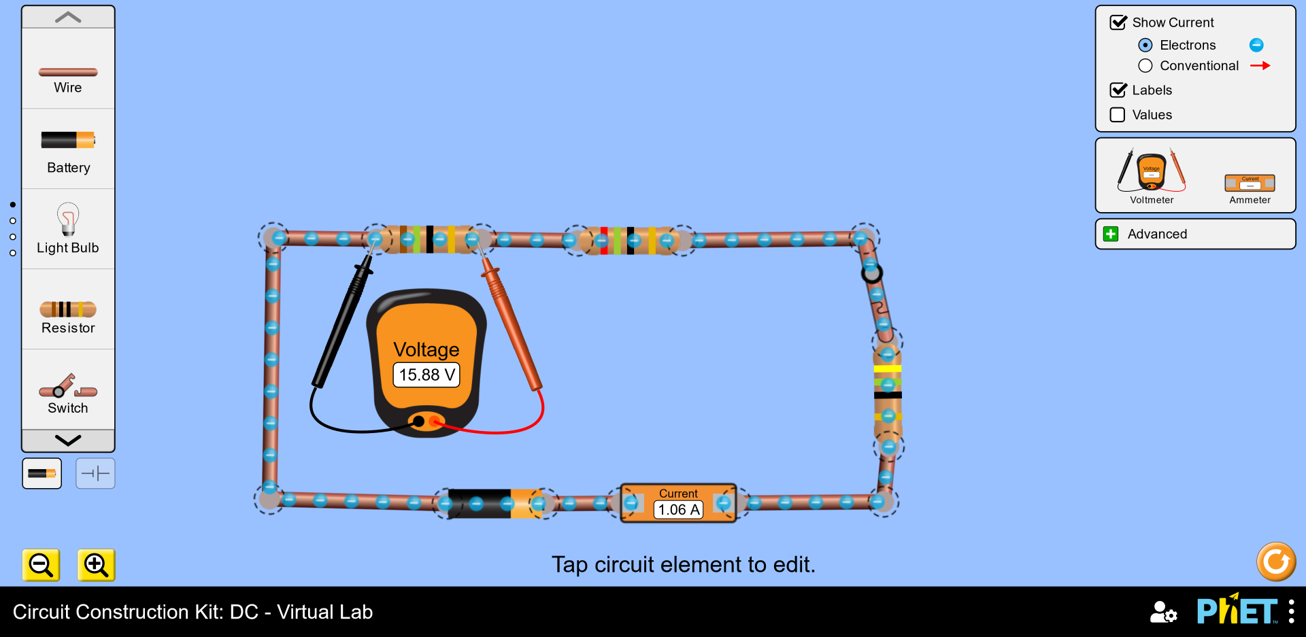
Below are images of all of the theories in the circuit lab:
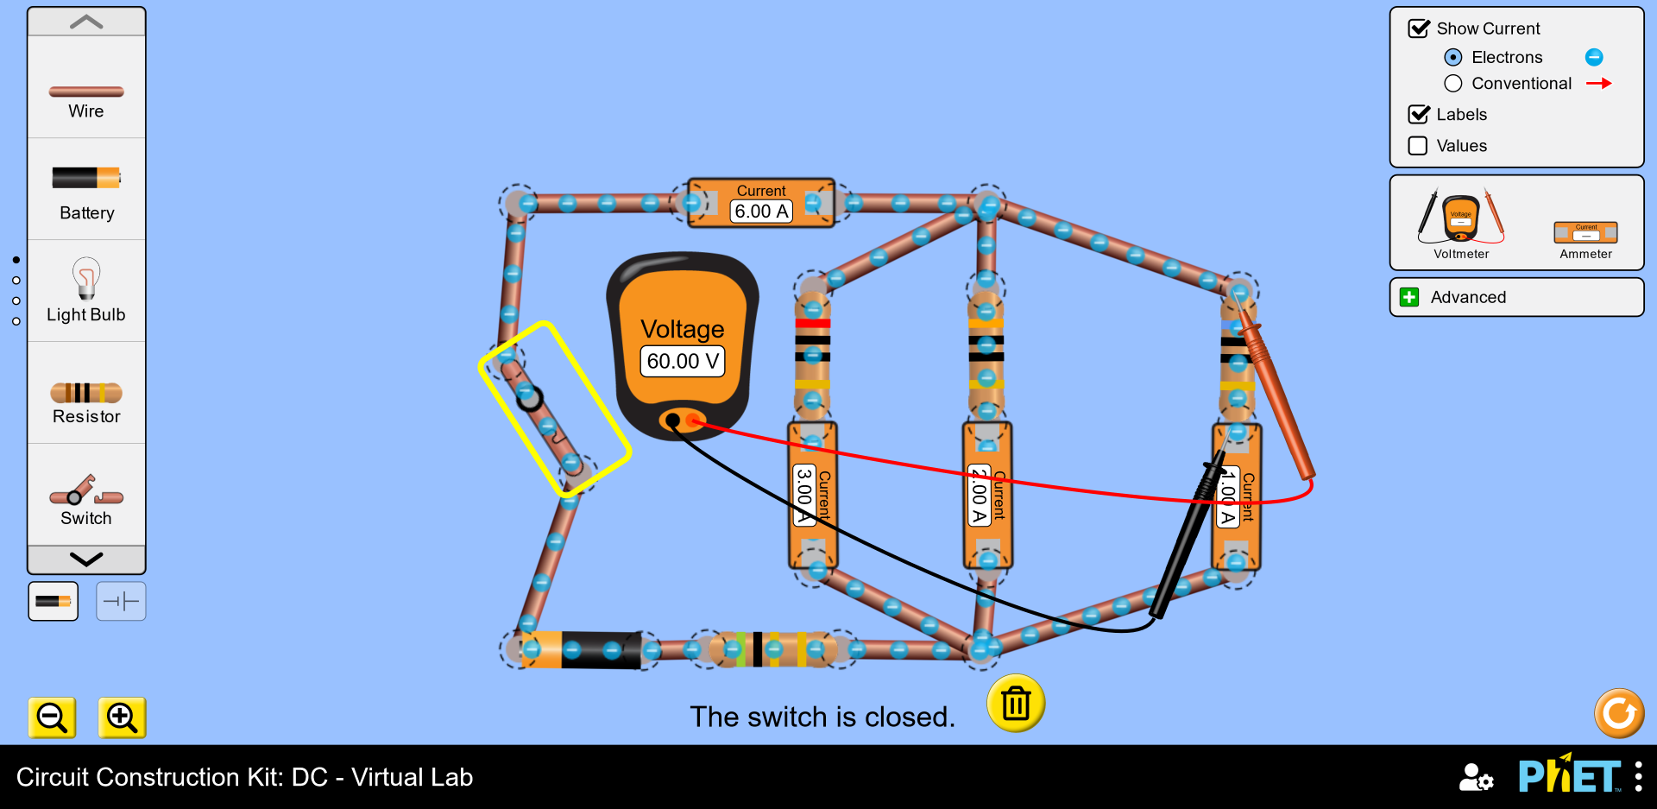

Next 2 on the same page.
